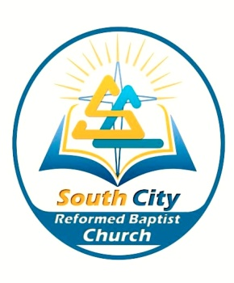
South City Reformed Baptist Church
Family Camp Registration Form
8pm Friday 27th – 4pm Sunday 29th March 2015
Pirongia Forest Park

Camper’s Name
Food allergies or special requirements (ie. Gluten free, vegetarian):

The cost for the 2 night stay is
Adult $50
Child (under 16) $20
The cost for day stay only is
Adult $20
Child (under 16) $12
This is payable to bank account 38-9016-0362330-00 by 28th of February 2015. Registrations received after this date will incur a $10 late fee.
Please aim to make it to camp by 8pm on Friday night.
Rules:
All campers will be expected to participate in chores.
Courtesy, respect, good manners and a cooperative attitude are expected of all campers. Boys and girls are not allowed in one another’s dorm areas. Defacing of camp property will not be tolerated. The possession of weapons, alcohol or illegal drugs is prohibited. Physical violence and fighting is not permitted.
Any camper who refuses to abide by the camp rules will be sent home without refund. Parents/Guardians will be notified and expected to honour this action by picking their child up promptly.

What to bring:
A positive attitude
Bible, notebook, pen
Clothing for 2 days
Warm jacket
Sleeping bag, Pillow
Towel, Toiletries
Walking shoes
Sunblock
Some home baking to share

Directions:
https://www.google.co.nz/maps/dir/-37.6105096,175.1857456/Pirongia+Forest+Park+Lodge,+297+Grey+Rd,+Waikato+3285/@-37.7463943,175.1830383,10z/am=t/data=!4m9!4m8!1m0!1m5!1m1!1s0x6d6cdbd3682f859d:0x6566bfbe10c57e25!2m2!1d175.149402!2d-37.968299!3e0?hl=en
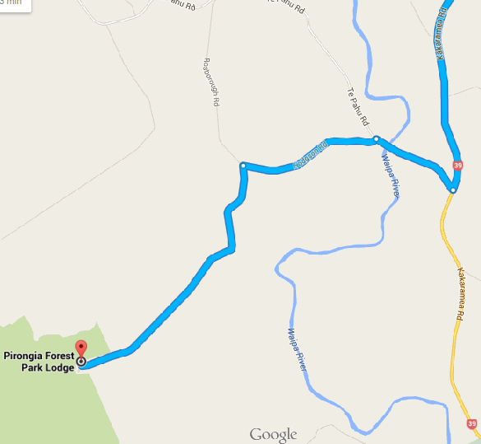
If you hit the Pirongia township, you’ve gone too far!

